Data Structures Introduction:

1. Data Structures
2. Database – arranging data in primary storage so it can be retrieved or accessed by applications easily
3. Datawarehouse – operational and legacy data, can be kept on array of storage drives
4. Big Data

Data Structures: arrangement of the collection of data items so you can perform operations on the data efficiently in memory

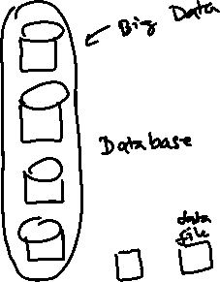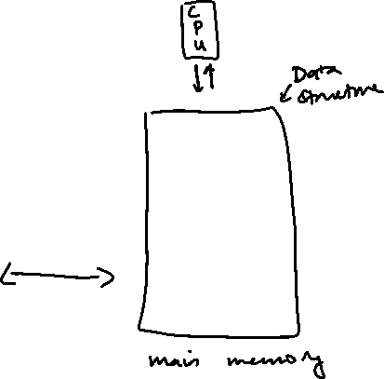

Static & Dynamic memory allocation:

1. About Main Memory
   1. Memory divided into bytes, each byte has an address (addresses are linear, i.e. only one coordinate, not x & y)
   2. Size of a memory segment is 64 kilobytes

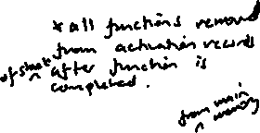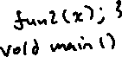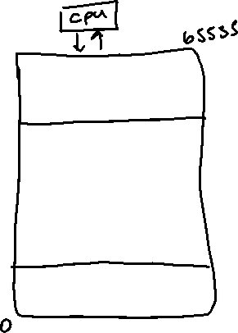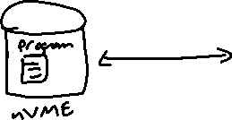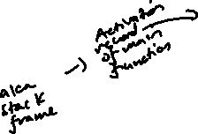

1. How a program uses memory
2. Static Allocation
3. Dynamic Allocation

